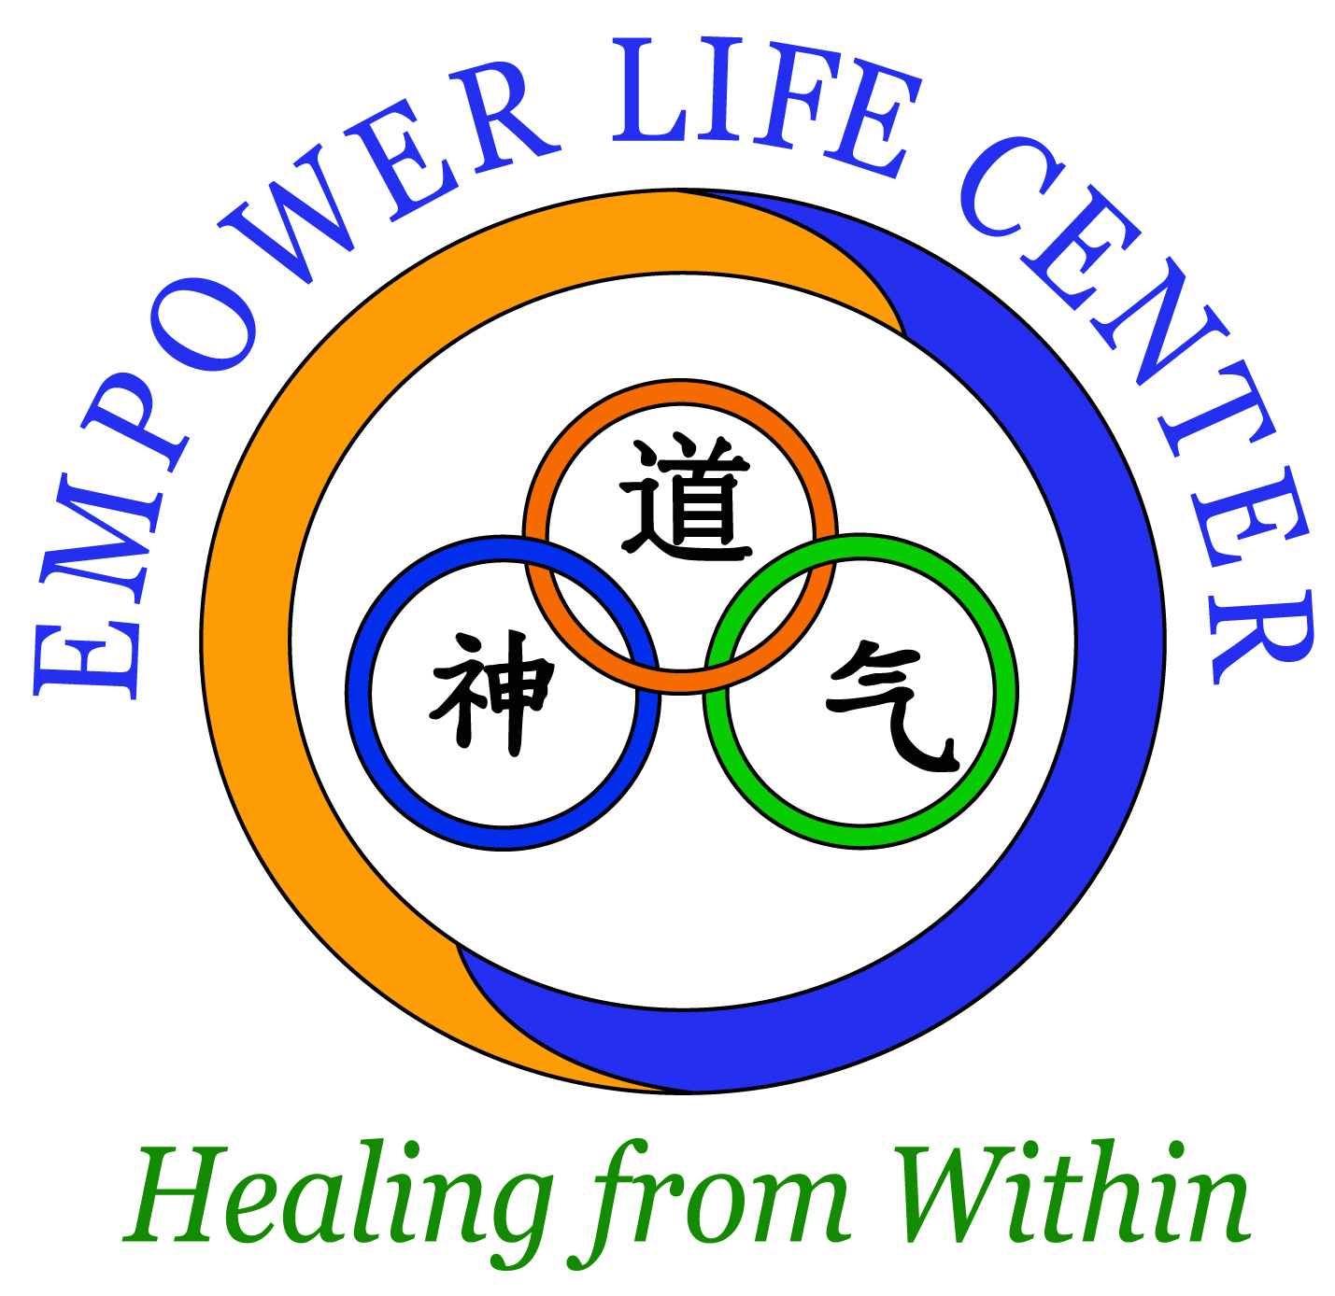

About Us
We are a local mind and body wellness company specializing in developing and implementing corporate Tai Chi wellness programs, stress management, and mind-body wellness coaching. We are conveniently located in the Ballantyne area and just minutes from you.

Our Expertise
Our unique background in holistic medicine and 26 years of experience in mind-body wellness and Tai Chi gives a unique perspective and understanding about the importance of the mind-body connection in both preventing chronic health disorders and promoting optimal wellness.

Why Tai Chi?
Unlike most fitness programs that emphasize muscle strength and cardiovascular conditioning, Tai Chi focuses on simultaneously improving health, enhancing wellness, and balancing the mind. In an article Time Magazine called Tai Chi “the perfect exercise” because it balances the body, life energy, and mind all at the same time. And while it is true that most forms of exercise are beneficial for stress reduction, it is the mind-body connection that is the core of Tai Chi practice. Tai Chi is relatively easy to do, fun to practice, and simple to implement. The Corporate Tai Chi Wellness Program can be easily adapted to suit your particular needs, requires no especial or costly equipment, can be practiced indoors or outdoors, and is safe for all ages and fitness levels.

Contact Us
Contact us today at 704-542-8088 or email us at info@empowerlifecenter.com to find out how we can help your company reach its mind and body health and wellness goals.

In mind and body wellness,
Camilo Sanchez, L. Ac, MOM
Director Empower Life Center
OUR COMPANY
The Empower Life Center specializes in holistic medicine, acupuncture, and Tai Chi wellness programs. Our expertise includes integrative medicine, acupuncture, stress management, preventative therapies, personalized nutrition, and mind-body wellness coaching.

We are excited to be offering our Tai Chi corporate wellness program. Conveniently located in the Ballantyne area, we are happy to travel to your organization, and offer on-site Tai Chai classes. Our Tai-Chi wellness program is tailored to the specific needs of your organization and our extensive expertise in this field ensures that your employees will greatly benefit from learning this ancient yet relevant health practice.

THE COST OF UNMANAGED WELLNESS
- In a report by Forbes citing a study by the Integrated Benefits Institute, US corporations lose $576 billion annually due to sick days, absenteeism and disability.
- It is estimated that U.S. businesses spend more than $300 billion annually due to stress related illnesses and absenteeism. $232 billion are due to chronic and mostly preventable conditions such as diabetes, heart disease, and depression.
- In 2014 the total number of working days lost from illness or injuries was 28.2 million. The majority of conditions reported include stress, depression, anxiety and musculoskeletal disorders. The average days lost per case for stress,

78% of employees say they are interested in company sponsored wellness programs.
depression or anxiety was 23 days, greater than for musculoskeletal disorders
(16 days).
- According to Towers Watson, the health care cost for employees will rise between 4% - 5.2% % in 2015.
- It is estimated that up to 70% of healthcare costs are caused by preventable illnesses.
- Health disorders due to stress account for between 70 to 85% of doctor visits.
Every dollar invested in workplace wellness initiatives yields between $3 - $6 return on investment.
- Nowadays it has been clearly established that chronic stress is one of the leading causes or a major contributing factor in diseases such as high blood pressure, heart disease, diabetes, elevated cholesterol, digestive disorders, gastro-intestinal ulcers, arthritis, asthma, hormonal imbalances, fatigue, chronic pain, cancer, and other conditions.
- Fewer visits to health care providers for illnesses or preventable conditions can lower the premium companies pay for their health coverage.

TAI CHI-BASED CORPORATE WELLNESS
- Most chronic health disorders can be prevented and improved through a combination of exercise, stress reduction, nutrition, and a healthy lifestyle.
- Unlike most exercise programs that emphasize muscular strength and cardiovascular conditioning, Tai Chi focuses on simultaneously improving health, enhancing fitness, and balancing the mind.
- In an article Time Magazine called Tai Chi “the perfect exercise” because it conditions the body, life energy, and mind all at the same time.
- While it is true that most forms of exercise are beneficial for stress reduction, it is the mind-body connection that is the core of Tai Chi practice.
- Tai Chi is one of the most efficient mind and body exercises to reduce stress, improve mood, and promote psychological well-being.
- Tai Chi involves a sequence of choreographed, flowing and low-impact movements using the body’s own weight combined with deep breathing and mind focus.
Healthier employees are happier and more productive people with a better attitude in the work place.
- Though a gentle form of exercise, surprisingly, Tai Chi burns a significant amount of calories, about 280 per hour. Yet, Tai Chi is gentle enough to be done in business clothes in the office without breaking a sweat.
- Tai Chi is relatively easy to do, fun to practice, and simple to implement. A Corporate Tai Chi Wellness program can be easily adapted to suit your particular needs, requires no special or costly equipment, can be practiced indoors or outdoors, and is safe for all ages and fitness levels.

EVIDENCE-BASED WELLNESS
- There is a growing body of scientific research about the beneficial health outcomes of a regular Tai Chi exercise. “A growing body of carefully conducted research is building a compelling case for Tai Chi as an adjunct to standard medical treatment for the prevention and rehabilitation of many conditions”, says Peter M. Wayne, assistant professor of medicine at Harvard Medical School.
- The Journal of Psychosomatic Research reported that on a study of Tai Chi, “test subjects experienced less tension, depression, anger, fatigue, confusion and anxiety; they felt more vigorous and had less mood disturbances”. According to the same study, Tai Chi fosters better mood and psychological well-being. Given that chronic stress accounts for between 70 – 85% of doctor visits, Tai Chi is increasingly being utilized in health care and corporate wellness as preventative medicine.
- The National Institutes of Health (NIH) has increased funding to further research the ancient, yet currently relevant practice of Tai Chi. For example, in a ten years study conducted through Harvard, Yale and Emory Universities, researches were stunned when they discovered that the gentle, flowing, low-impact exercise of Tai Chi markedly improved balance and reduced the risk of falling by 47.5%.
- An article by the Mayo Clinic staff lists 16 major health outcomes of Tai Chi exercise.

THE BENEFITS OF A TAI CHI-BASED WELLNESS PROGRAM
- Reduces stress and its related health disorders.
- Decreases the number of visits to health care providers for illnesses and preventable health conditions.
- Helps reduce medical expenses and loss of work hours due to sickness and absenteeism.
- May help to lower the premiums of health care benefits and co-payments for employees.
- Increases physical and mental relaxation leading to a better attitude and improved productivity in the work place.
- Improves overall markers of wellness such as blood sugar, cholesterol, blood pressure, heart health, immune system, vital lung capacity, sleep, energy level and mental concentration.
- Healthier employees generally means lower utilization of the company’s health plan, thus lowering the cost of providing health insurance, and increasing the company’s bottom line.
- And all of these in the convenience of your own work place!

The bottom line for offering a Tai Chi-based wellness program is simple – healthy employees are happier employees, and they are what make a corporation run.

CONTACT INFORMATION
To find out how we can help your company implement an effective Corporate Tai Chi Wellness Program call our office today at 704-542-8088 or contact us at info@empowerlifecenter.com. We will be happy to work with you.

In mind and body wellness,

Camilo Sanchez, L. Ac, MAOM
Director Empower Life Center

